


SALES PERFORMANCE
DASHBOARD
POWER BI PROJECT
---------------------------------------------------------------

This project demonstrates my ability to use Power BI for data analysis and dashboard development. I imported the dataset from Excel, transformed it using Power Query, created DAX measures, and designed interactive visualizations to analyze sales performance and support data-driven decision-making.

Source | Kaggle (Sales Dataset)
Records | 107
Columns | 8
Data Range | 29-7-2023 to 31-12-2025
Data type | Excel(.xlsx)
Tools used | Microsoft Excel  Power BI desktop  Power Query  DAX
DATASET INFORMATION

DATA DICTIONARY
Customer Name | Name of the customer who purchased the product.
Product | Name of the product sold.
Sales Data | Date of the sales transition.
Sales Channel | Sales Channel used for the transition.
State | State where the sale occurred.
Total Sales | Total revenue generated from the sale.
Unit Price | Price of one unit of the product.
Units Sold | Quantity of units sold in the transition.

DAX MEASURES USED
- Total Sales = SUM(Sales[Total Sales])
- Total Units Sold = SUM(Sales[Unit Sold])
- Total Customers = DISTINCTCOUNT(Sales[Customer Name])
- Average Unit Price = AVERAGE(Sales[Unit Price])
- Maximum Sale = MAX(Sales[Total Sales])
- Minimum Sale = MIN(Sales[Total Sales])
- Total Products = DISTINCTCOUNT(Sales[Product])
- Online Sales = CALCULATE(Sales[Total_Sales],[Sales_Channel]= “Online”)
- Retail Sales = CALCULATE(Sales[Total_Sales],[Sales_Channel]= “Retail”)
- Wholesale Sales = CALCULATE(Sales[Total_Sales],[Sales_Channel]= “Wholesale”)
- Average Unit Sold = AVERAGE(Sales[Units sold])

DATA CLEANING SUMMARY
- Removed duplicate values.
- Handled missing values.
- Corrected data types.
- Removed unnecessary columns.
- Renamed columns for better quality.

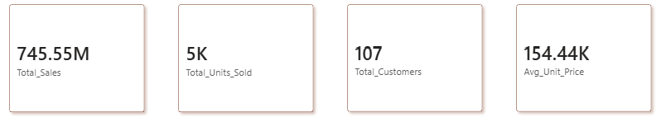
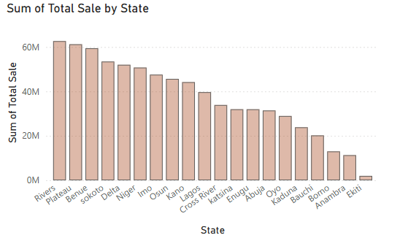
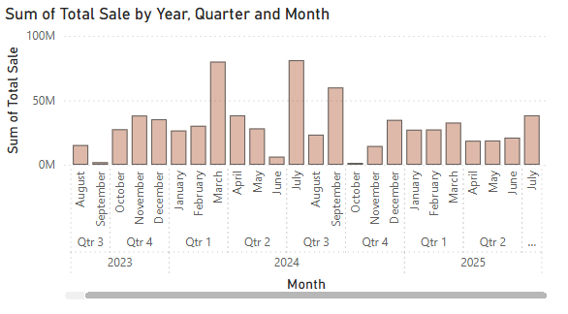
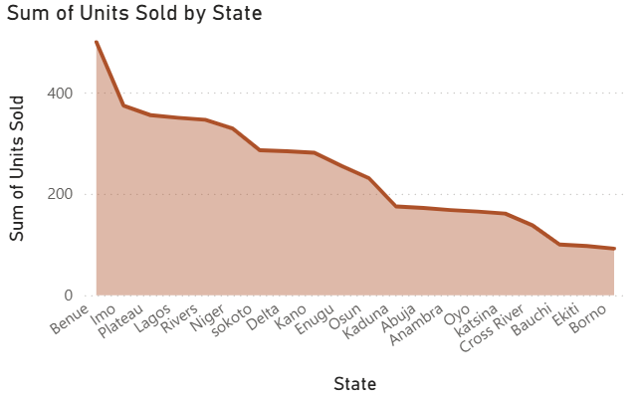
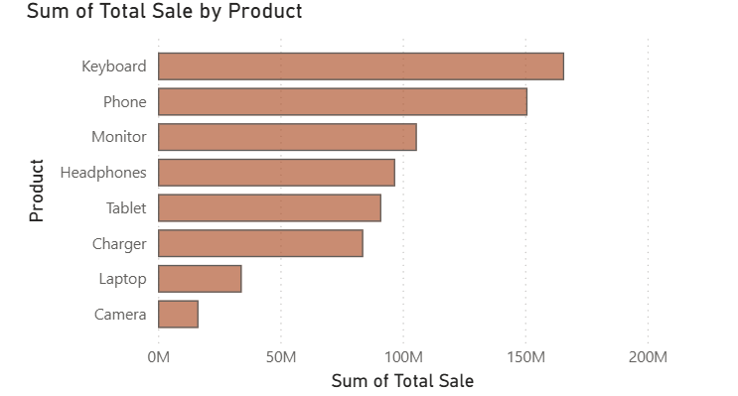
DASHBOARD PREVIEW
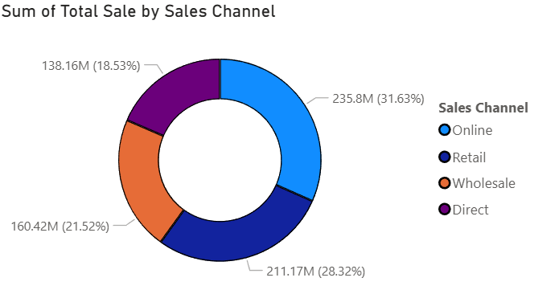
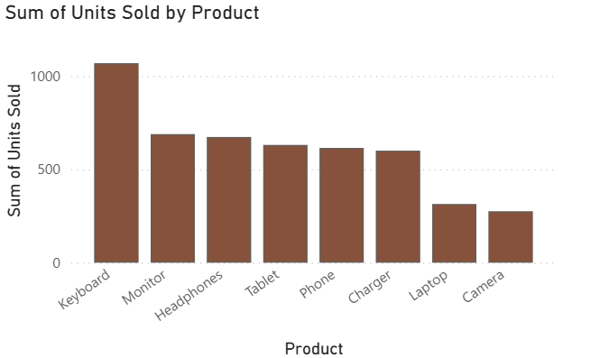

PROJECT SUMMARY

In this project, I developed an interactive Sales Performance Dashboard using Power BI to analyze sales data. I imported and prepared the dataset, created DAX measures to calculate important KPIs, and designed interactive visualizations such as KPI cards, bar charts, line charts, donut charts and tables. The dashboard provides a comprehensive view of sales performance by product, customer, state, and sales channel, making it easier to monitor trends and evaluate business performance.

PROJECT OUTCOME

As a result of this project, I created an evaluation of sales performance through interactive reports. I demonstrated the ability to apply data visualization techniques, business intelligence concept, and analytical thinking to extract meaningful insights from the dataset. This project strengthened my practical experience with Power BI, DAX, Power Query, and dashboard design, while showcasing my ability to present business data in a clear and impactful manner.

